View State

View State is the method to preserve the Value of the Page and Controls between round trips. It is a Page-Level State Management technique. View State is turned on by default and normally serializes the data in every control on the page regardless of whether it is actually used during a post-back.

Now I am showing you an example of what the problem is when we don't use view state.

Step 1

Open Visual Studio 2010.

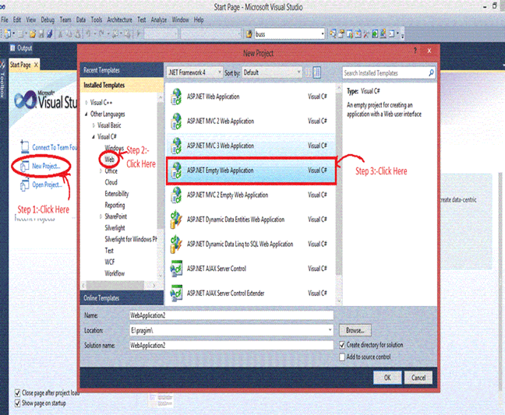

Step 2

Then click on "New Project" > "Web" >"ASP.NET Empty Web Application".

Step 3

Now click on Solution Explorer.

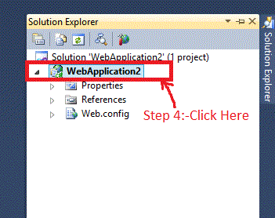

Step 4

Now right-click on the "ADD" > "New Item" > "Web Form" and add the name of the Web Form just like I did in WebForm6.aspx.

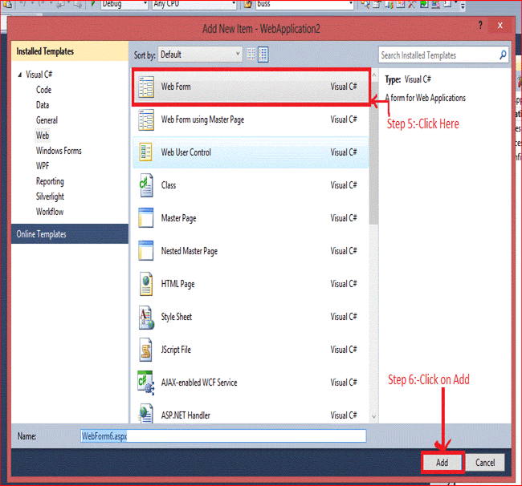

Step 5

After adding the WebForm6.aspx you will see the following code:
- <%@ page language="C#" autoeventwireup="true" codebehind="WebForm6.aspx.cs" inherits="view_state.WebForm6" %>

- <!DOCTYPE html PUBLIC "-//W3C//DTD XHTML 1.0 Transitional//EN" "http://www.w3.org/TR/xhtml1/DTD/xhtml1-transitional.dtd">
- <html xmlns="http://www.w3.org/1999/xhtml">
- <head runat="server">
- <title></title>
- </head>
- <body>
- <form id="form1" runat="server">
- <div>
- User Name:-<asp:textbox id="TextBox1" runat="server"></asp:textbox>
- <br />
- Password :-<asp:textbox id="TextBox2" runat="server"></asp:textbox>
- <br />
- <asp:button id="Button1" runat="server" onclick="Button1_Click" text="Submit" />
- <asp:button id="Button3" runat="server" onclick="Button3_Click" text="Restore" />
- </div>
- </form>
- </body>
- </html>
Now write the code as in the following,
- //Declaration of a and b
- public string a, b;
- protected void Button1_Click(object sender, EventArgs e)
- {
- //TextBox1 and TextBox2 Value is Assigning on the variable a and b
- a = TextBox1.Text;
- b = TextBox2.Text;
- //after clicking on Button TextBox value Will be Cleared
- TextBox1.Text = TextBox2.Text = string.Empty;
- }

- protected void Button3_Click(object sender, EventArgs e)
- {
- //value of variable a and b is assingning on TextBox1 and Textbox2
- TextBox1.Text = a;
- TextBox2.Text = b;
- }
Output

Now the output is,

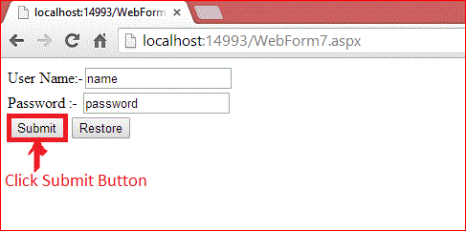

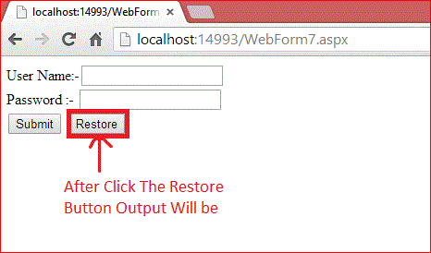

It only happens because all the controls are classes and on the server all the Control Objects are created and then after the round trip the Page is returned to the client's browser in HTML format and the objects are destroyed at the server.

After the Submit button is clicked the value of user name and password is submitted to the server. We cannot restore the value again because after the postback the instance of the control is destroyed and on clicking of the Restore Button the server takes a new request and the server cannot restore the value of the TextBox.

Features Of View State

These are the main features of view state,
- Retains the value of the Control after post-back without using a session.
- Stores the value of Pages and Control Properties defined in the page.
- Creates a custom View State Provider that lets you store View State Information in a SQL Server Database or in another data store.
And now I am explaining the stored value in the View State and the remaining steps are the same as the previous.

Now write this code,
- protected void Button1_Click(object sender, EventArgs e)
- {
- //Value of Textbox1 and TectBox2 is assigin on the ViewState
- ViewState["name"] = TextBox1.Text;
- ViewState["password"] = TextBox2.Text;
- //after clicking on Button TextBox value Will be Cleared
- TextBox1.Text = TextBox2.Text = string.Empty;
- }
- protected void Button3_Click(object sender, EventArgs e)
- {
- //If ViewState Value is not Null then Value of View State is Assign to TextBox
- if (ViewState["name"] != null)
- {
- TextBox1.Text = ViewState["name"].ToString();
- }
- if (ViewState["password"] != null)
- {
- TextBox2.Text = ViewState["password"].ToString();
- }
- }
Output

Now the output is,

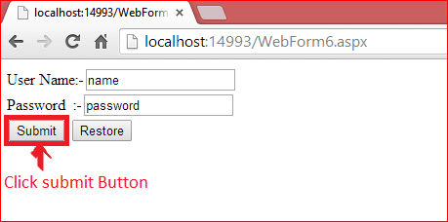

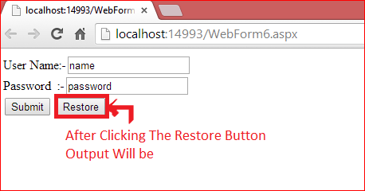

After clicking on the Submit Button the value of user name and password is submitted in View State and the View State stores the value of user name and password during post-back.

After click on the Restore Button we can get the value again. The Value must be retained during post-back and the values are stored into a base 64 encoded string and this information is then put into the View State Hidden Field.

